**Setting up Amazon WorkMail Inbound Rules:**

1. Click on ‘Organization Settings’ from the menu and in General section you will see the web-application link for your email.

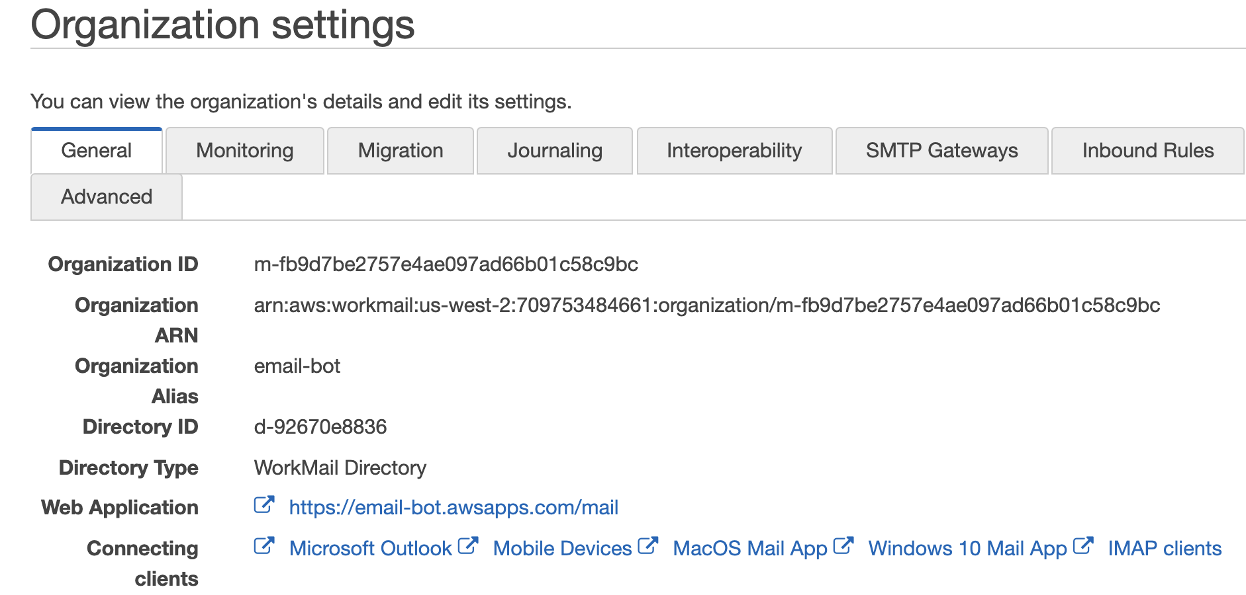

1. Click on that web-application URL to login and enter the username and password and Sign In

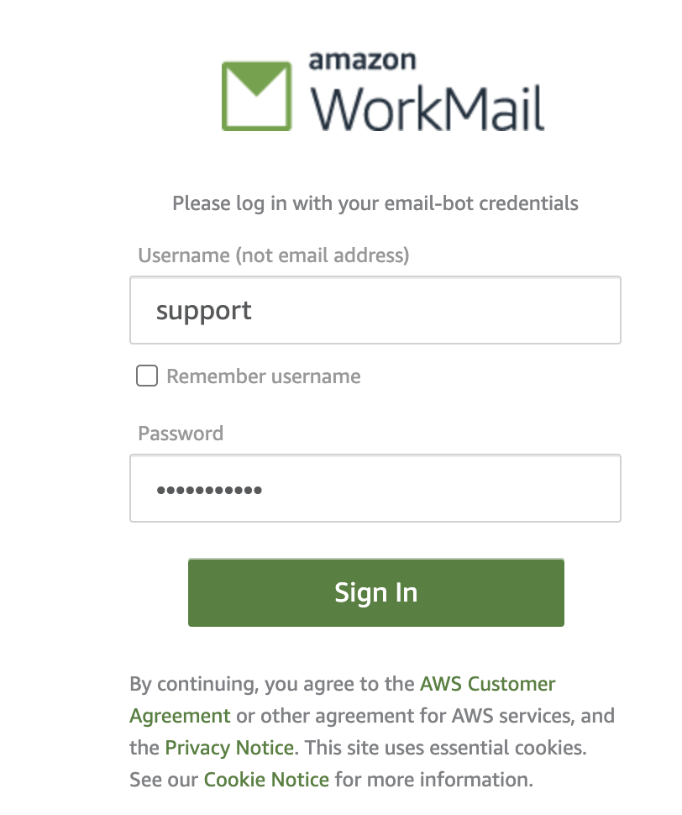

1. You will see your Email inbox web page

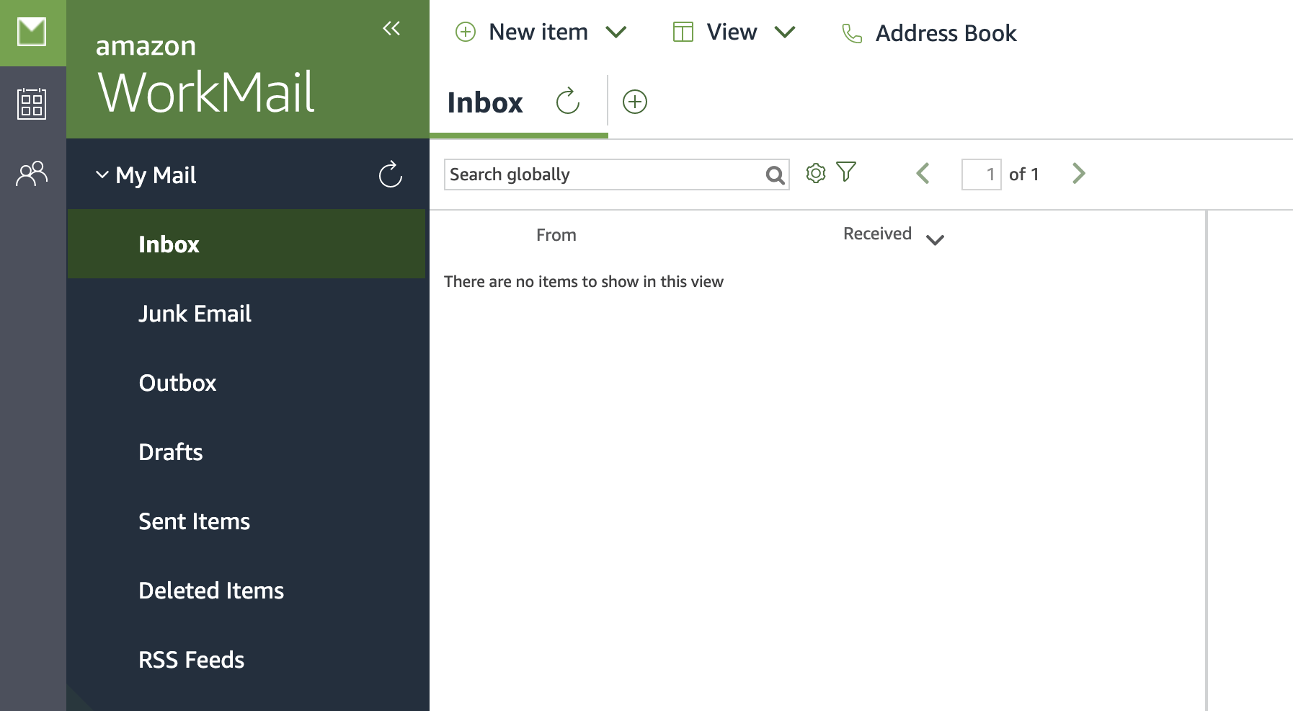

1. Test this new email box by sending email from your personal email id.
2. Setting up Inbound Rules:

* Click on ‘Organization Settings’ and choose the ‘Inbound Rules’ menu
* Click the button ‘Create rule’
* Enter the Rule Name and Select the action ‘Run Lambda’ and choose ‘Custom Lambda function’ and select the lambda function generated in the previous stack deployment.
* This Lambda function will be invoked upon receiving the email on this domain
* Enter * in both Sender domain and destination domain